SWOWEA “Online” Section Meeting
Thursday, March 18, 2021

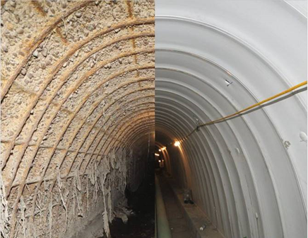

Host: SWOWEA

Registration: www.owea.org

Initial registration will be as usual.

Since this is a virtual event, after you register at OWEA you will be sent a link to register with “Go To Webinar” sometime before the event. You will need to register at both OWEA and later at “Go To Webinar”.

Attendees will need to respond to polling questions during and at the end of each presentation.
_____________________________________________

Technical Sessions:
Sessions will begin at 9:00 AM and last until 11:00 AM.
OEPA contact hours are being applied for each of the technical sessions.

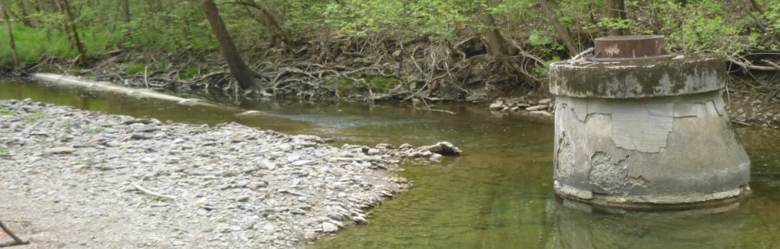

Technical Sessions:

9:00 am – 9:45 am – Navigating the Challenges of an Emergency Interceptor Repair– David Hafner PE, Brown and Caldwell
OEPA-XXXXXXXXX-OM – 0.75 hrs

9:45 am – 10:30 am – Scioto County Interceptor Rehabilitation- Glenn Weist PE, Dynotec
OEPA-XXXXXXXXX-OM – 0.75 hrs

10:30 am – 11:00 am – Protecting Sewers from Emerging Stream Erosion Threats- Dean Flores, Montgomery County Environmental Services, and Adam Athmer, Strand Associates
OEPA-XXXXXXXXX- OM – 0.5 hrs

Register by March 11, 2021 at www.ohiowea.org.

Registration fees are $30.

Registration is capped so it may close early if event is filled.

Contact: Justin Bahar, SWOWEA Treasurer at Justin.Bahar@cincinnati-oh.gov or (513) 801-3458.

Credit card payment is available through www.ohiowea.org only.

Please honor your reservation with payment if
unable to attend.

Thanks to the Collections Committee!

